Hangman Game

Introduction :

**Hangman** is a popular word guessing **game** where the player attempts to build a missing word by guessing one letter at a time. After a certain number of incorrect guesses, the **game** ends and the player loses. The **game** also ends if the player correctly identifies all the letters of the missing word.

the idea of **hangman** is that one player thinks of a **word** and tells the other player how many letters it has. The second player repeatedly guesses letters. If a guessed letter is in the **word**, the **word** chooser must reveal the position of every occurrence of the letter in the **word**

Implementation :

This is a project Hangman game using Python programming language.

1. The Hangman program randomly selects a secret word from a list of secret words. The random module will provide this ability, so line 1 in program imports it.
2. **The Game:** Here, a random word (a fruit name) is picked up from our collection and the player gets limited chances to win the game.
3. When a letter in that word is guessed correctly, that letter position in the word is made visible. In this way, all letters of the word are to be guessed before all the chances are over.
4. For convenience , I have given length of word + 2 chances. For example, word to be guessed is mango, then user gets 5 + 2 = 7 chances, as mango is a five letter word.

Code :

# Python Program to illustrate

# Hangman Game

import random

from collections import Counter

someWords = '''apple banana mango strawberry

orange grape pineapple apricot lemon coconut watermelon

cherry papaya berry peach lychee muskmelon'''

someWords = someWords.split(' ')

# randomly choose a secret word from our "someWords" LIST.

word = random.choice(someWords)

if __name__ == '__main__':

    print('Guess the word! HINT: word is a name of a fruit')

    for i in word:

         # For printing the empty spaces for letters of the word

        print('_', end = ' ')

    print()

    playing = True

     # list for storing the letters guessed by the player

    letterGuessed = ''

    chances = len(word) + 2

    correct = 0

    flag = 0

    try:

        while (chances != 0) and flag == 0: #flag is updated when the word is correctly guessed

            print()

            chances -= 1

            try:

                guess = str(input('Enter a letter to guess: '))

            except:

                print('Enter only a letter!')

                continue

            # Validation of the guess

            if not guess.isalpha():

                print('Enter only a LETTER')

                continue

            elif len(guess) > 1:

                print('Enter only a SINGLE letter')

                continue

            elif guess in letterGuessed:

                print('You have already guessed that letter')

                continue

            # If letter is guessed correctly

            if guess in word:

                k = word.count(guess) #k stores the number of times the guessed letter occurs in the word

                for _ in range(k):

                    letterGuessed += guess # The guess letter is added as many times as it occurs

            # Print the word

            for char in word:

                if char in letterGuessed and (Counter(letterGuessed) != Counter(word)):

                    print(char, end = ' ')

                    correct += 1

                # If user has guessed all the letters

                elif (Counter(letterGuessed) == Counter(word)): # Once the correct word is guessed fully,

                                                                # the game ends, even if chances remain

                    print("The word is: ", end=' ')

                    print(word)

                    flag = 1

                    print('Congratulations, You won!')

                    break # To break out of the for loop

                    break # To break out of the while loop

                else:

                    print('_', end = ' ')

        # If user has used all of his chances

        if chances <= 0 and (Counter(letterGuessed) != Counter(word)):

            print()

            print('You lost! Try again..')

            print('The word was {}'.format(word))

    except KeyboardInterrupt:

        print()

        print('Bye! Try again.')

        exit()

Output 1

When 'Guess the word! HINT: word is a name of a fruit'

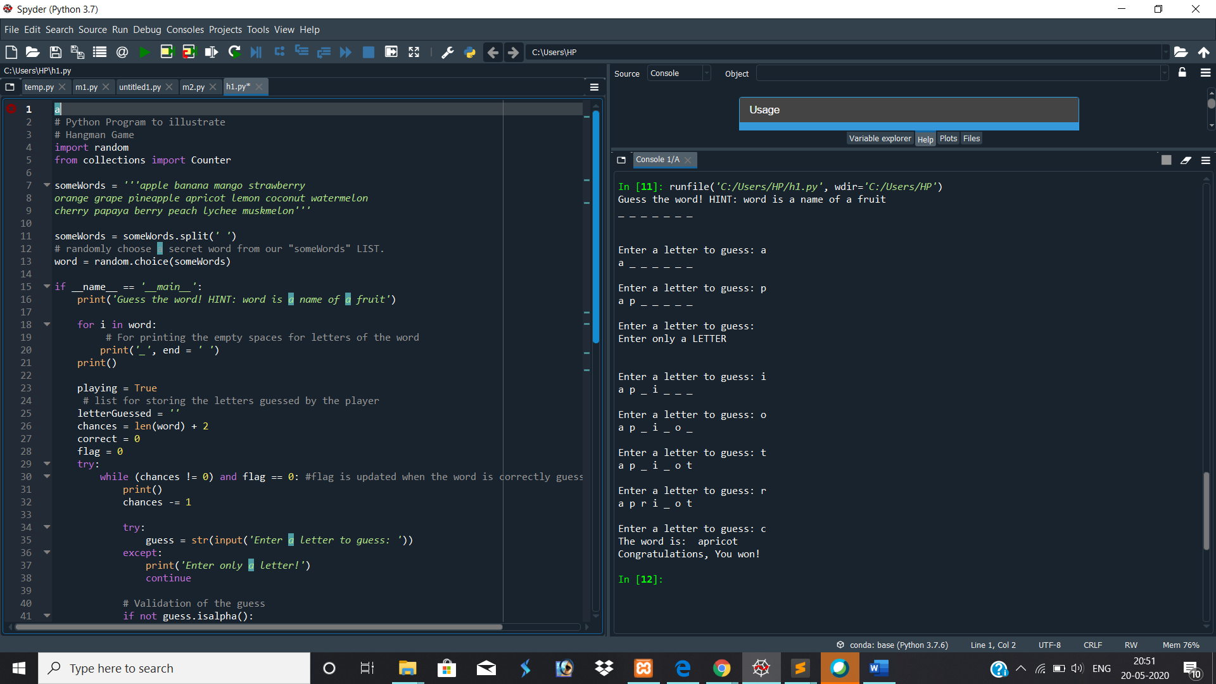

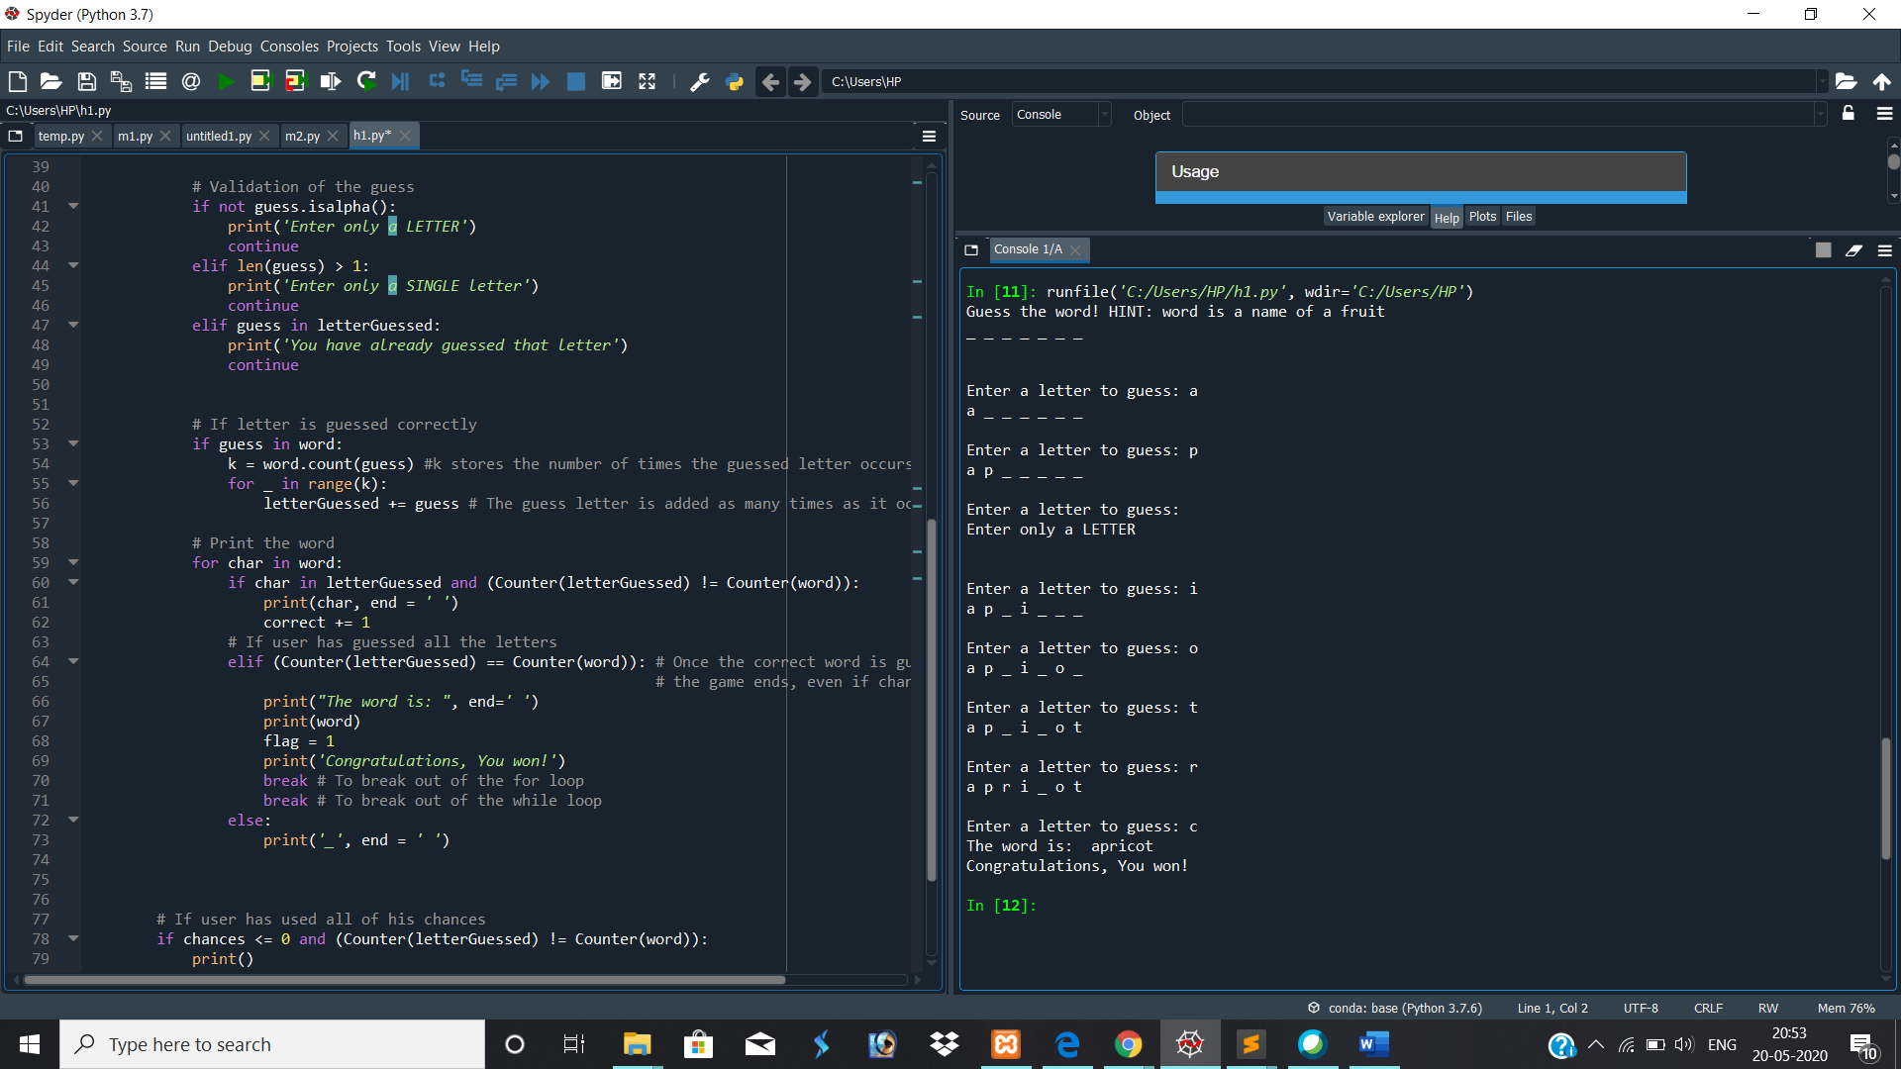

Result : apricot

Output 2

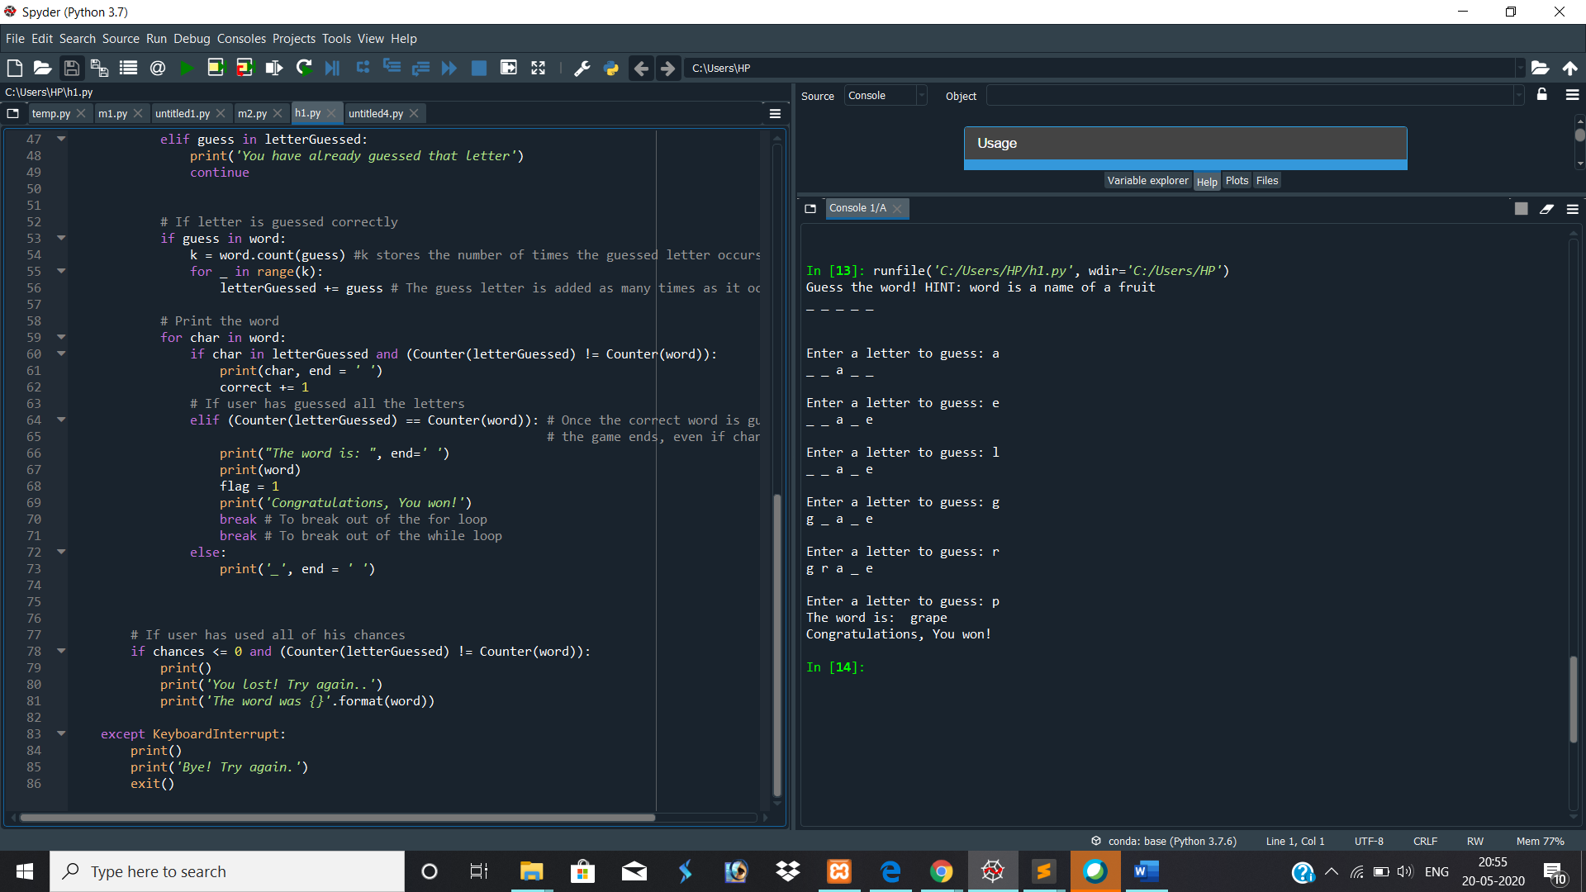

Result : grape